Primary 7’s Trip To Lagganlia – March 2024
On Monday 18 March, I am going to Lagganlia. I will stay there for 4 nights.
Everyone in Primary 7 at Flora’s has had the chance to come, and most are choosing to go to camp.

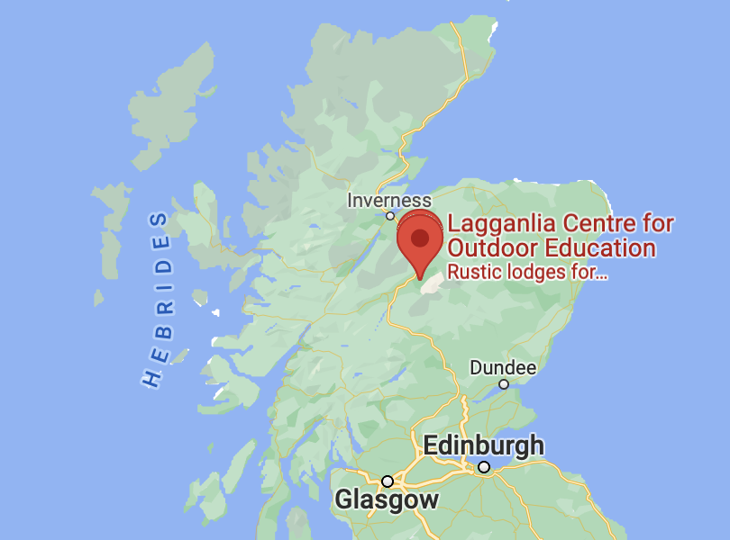
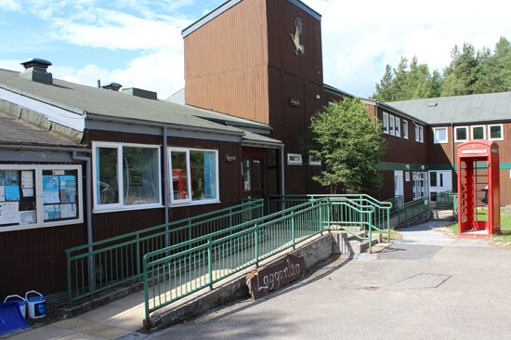

Monday morning

On Monday, we will meet in the Dinner Hall at 8.50am. My family can come into the hall with me. It will get quite busy. I will have my big bag with all my clothes. I will have a small bag with a snack, water bottle and a packed lunch to take on to the bus. I will not be able to take anything out of my big bag until we get to Lagganlia because it will be in the hold under the bus.

The Journey
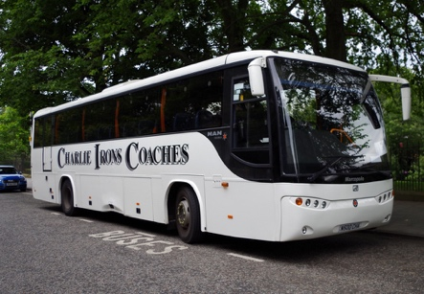
We will get on the bus at 9.20am. We will be on the bus for nearly 2 hours until we get to Pitlochry for a break and to stretch our legs. It might take longer if there is traffic on the road. When we stop in Pitlochry, we will get out of the bus with adults. It can be a busy car park, so adults will help us get off the bus to a safe place. We will get off the bus and go to the toilet.
We will get back on the bus and continue driving to Lagganlia. We will be in the bus for about another hour. We will arrive at Lagganlia at about 12:30. I will take my big bag off the bus.

Arriving at Lagganlia
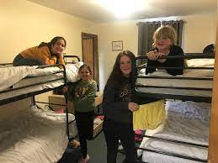
When we arrive, we will have our packed lunches. If the weather is good, we might have our lunch outside. If the weather is not good, we might have our lunch inside.
Then we will take our bags to our dorms. I will need to make my own bed. If I find this hard, I can ask for help from my dorm group.

Activity groups
I will find out my activity group and meet my group leader. I will be with the same group of people all week. I will do the first activity with my group on Monday afternoon.
After our activity on Monday afternoon, we will have some free time, dinner, activities and then go to bed.

Dorm Rooms
This is one of the rooms where pupils will sleep and get ready for activities. The rooms have either 2, 4 or 6 beds, and they all have their own shower and toilet. There is space to put your bags and drawers to put your clothes in. You and your dorm group will be responsible for keeping it neat and tidy. This room is called Druie. All the rooms are named after local rivers, forests and mountains.

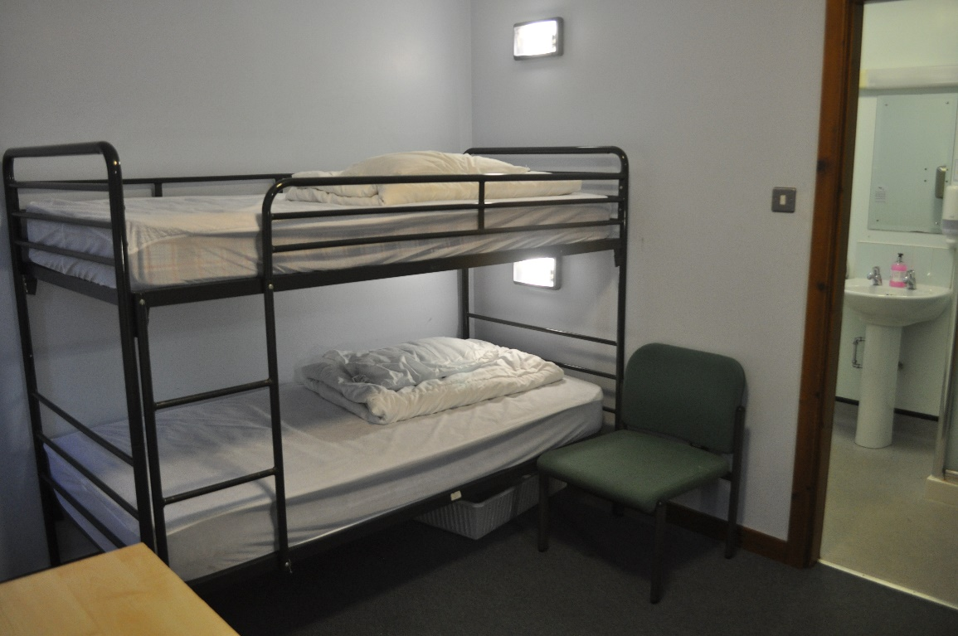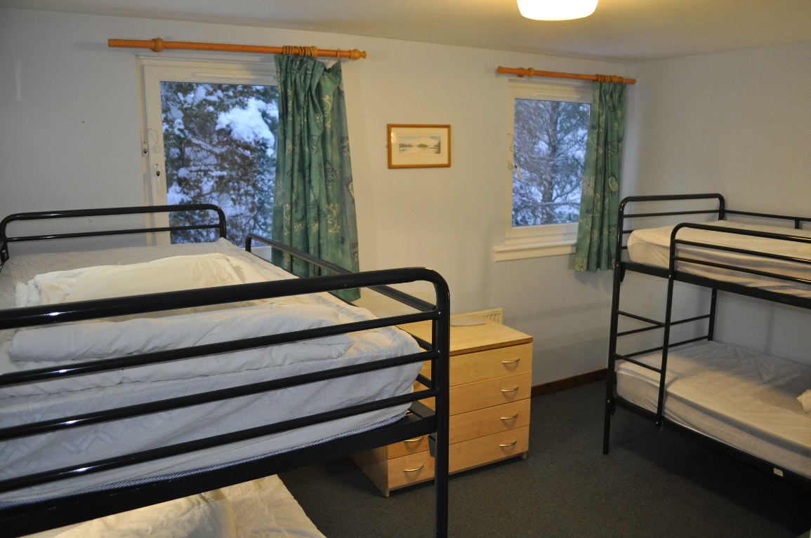

A typical day at Lagganlia
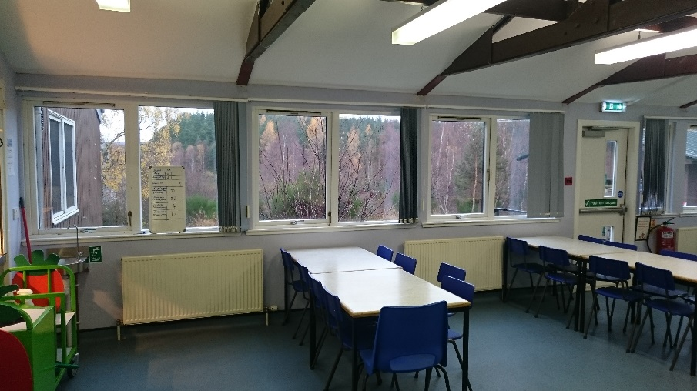
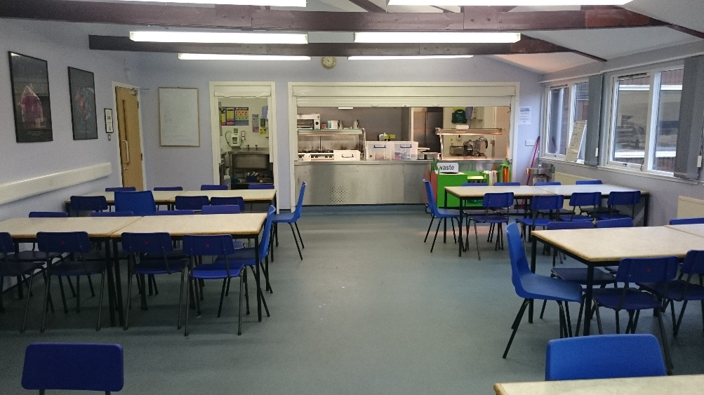
I will get up and get dressed. I might want to have a shower. I need to be in the dining room for breakfast at around 8:00. Staff from Flora’s will be around to make sure that everyone is ready.

For breakfast, there is toast and cereal. To drink there is also orange juice, milk and tea. If I want, I can choose to have a hot roll. This might be bacon, sausage or egg. I will choose the night before if I want to have a roll or not. The Lagganlia staff know everybody’s dietary requirements so there will be safe food for all.

After breakfast we will choose our packed lunches. I can take a roll from the fridge; the filling will be written on the label. I can take a packet of crisps, a piece of fruit, a piece of cheese, some crackers, and some biscuits. I might not like some of the options. This is okay, I can tell a member of school staff. They will help me to find food I can eat.

When I leave the dining room, I will go back to my dorm. My dorm group and I will tidy the dorm. One of the instructors will come to inspect my dorm. They will give us points if it is very tidy. At the end of the week, there might be a prize for the dorm with the most points.
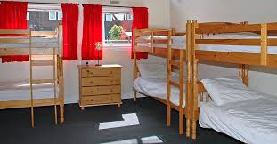

After dorm inspection I will go to meet my activity group and my instructor. My instructor will tell me what the activities are for the day. They will also tell me what I need to wear and what I need to bring. If I am not sure what they mean, I can ask them to repeat the instructions.

I will go back to my dorm and get ready for the day. I will wear and bring what my instructor has asked me to. If I forget, I can check with my group, my instructor, or the Flora’s staff member in my group. They will help me to get ready.
We will start activities. I might do one activity for the whole day, or I might do different activities in the morning and the afternoon.
My instructor will help us to be safe and learn to do new activities. It’s very important I listen to my instructor. If I don’t understand an instruction, I can ask them to repeat it. If I feel nervous or scared, this is OK. I can tell my instructor or a member of Flora’s staff. I might not feel like I can complete all the activities, this is OK.
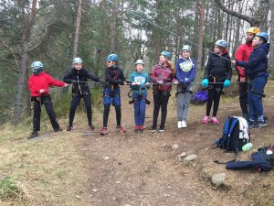


When the activities are finished, we will put the equipment away in the stores. If any of the equipment or any of my clothes are wet, I will put them in the drying room. I might need to have a shower or get changed if I am muddy or wet. For my clothes to dry, I need to hang them up properly. If I need help, I can ask my activity group, my instructor, or a teacher.

I might have some free time before dinner. I can play with my friends outside or stay inside. There will be drawing supplies and games inside. I can sit by myself and read if I want some time alone.

Dinner will be in the dining room. Some people will be chosen to help set the table. I will know what is for dinner before I sit down. I will choose between two options the night before. After dinner, some people will help to wipe and clear the table.

We will do activities after dinner. We might do some of the activities in our activity groups. There might be other people who are helping to organise activities. We might do some activities outside or we might stay inside.

Flora’s staff will check to make sure we are okay and tell us it is time to go to sleep. It is okay to keep a small light on if one of my dorm group feels scared. I can keep my own night light on all night if I want. When staff tell me to go to sleep, I need to try to sleep. If I don’t sleep, the next day will be very difficult as I need lots of energy for the activities.

If there is any problem in the night, it’s okay to waken one of the teachers up to tell them. I will know where the teachers are.
Lagganlia Sample Menu
Monday
      - Dinner Lentil soup
      - Steak Pie or vegetable pie served with Roast potatoes & peas
      - Supper Fruit loaf
Tuesday
      - Breakfast Cereal, square sausage roll, toast with preserves.
      - Packed lunch Filled wholemeal or white sandwich (choose from tuna, ham, egg or cheese with salad & pickles) fruit, crisps and biscuits.
      - Dinner Vegetarian bolognaise pasta served with salad & garlic bread or Fish served with potato croquettes and salad
      - Sticky Toffee pudding
      - Supper Flapjack
Wednesday
- Breakfast Cereal, scrambled egg roll, toast with preserves.
- Packed lunch Filled wholemeal or white sandwich (choose from tuna, ham, egg or cheese with salad & pickles) fruit, crisps and biscuits.
- Dinner Corn on the cob
- Chicken or vegetable curry served with rice or naan bread
- or macaroni cheese served with baby potatoes and green beans
- Supper Chocolate crispy cake
Thursday
- Breakfast Cereal, bacon roll, toast with preserves.
- Packed lunch Filled wholemeal or white sandwich (choose from tuna, ham, egg or cheese with salad & pickles) fruit, crisps and biscuits.
- Dinner Burger with roll or chips & salad
- Or vegetarian pizza with salad
- Cheesecake
- Supper Choc chip cookies
Friday
- Breakfast Croissants

We will leave Lagganlia after breakfast on Friday and we should be home by about 1.00pm. Flora’s staff will contact families by Groupcall to say where we are. Families will collect all the children from school.
When I get off the bus, I need to go into the school playground and wait with my family. It is a very busy time. I must make sure that I go and see a member of school staff to say goodbye so that they know I am safe before I go home.

